Elton, Gruber, Brown, and Goetzmann
Modern Portfolio Theory and Investment Analysis, 9th Edition
Solutions to Text Problems: Chapter 1

Chapter 1: Problem 1

A. Opportunity Set

With one dollar, you can buy 500 red hots and no rock candies (point A), or 100 rock candies and no red hots (point B), or any combination of red hots and rock candies (any point along the opportunity set line AB).

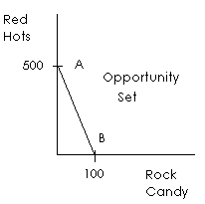

Algebraically, if X = quantity of red hots and Y = quantity of rock candies, then:

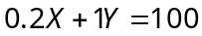

That is, the money spent on candies, where red hots sell for 0.2 cents a piece and rock candy sells for 1 cent a piece, cannot exceed 100 cents ($1.00). Solving the above equation for X gives:

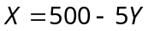

which is the equation of a straight line, with an intercept of 500 and a slope of −5.

B. Indifference Map

Below is one indifference map. The indifference curves up and to the right indicate greater happiness, since these curves indicate more consumption from both candies. Each curve is negatively sloped, indicating a preference of more to less, and each curve is convex, indicating that the rate of exchange of red hots for rock candies decreases as more and more rock candies are consumed. Note that the exact slopes of the indifference curves in the indifference map will depend an the individual’s utility function and may differ among students.

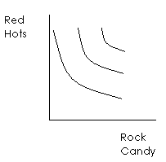

Chapter 1: Problem 2

A. Opportunity Set

The individual can consume everything at time 2 and nothing at time 1, which, assuming a riskless lending rate of 10%, gives the maximum time-2 consumption amount:

$20 + $20 × (1 + 0.1) = $42.

Instead, the individual can consume everything at time 1 and nothing at time 2, which, assuming a riskless borrowing rate of 10%, gives the maximum time-1 consumption amount:

$20 + $20 ÷ (1 + 0.1) = $38.18

The individual can also choose any consumption pattern along the line AB (the opportunity set) below.

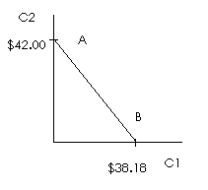

The opportunity set line can be determined as follows. Consumption at time 2 is equal to the amount of money available in time 2, which is the income earned at time 2, $20, plus the amount earned at time 2 from any money invested at time 1, ($20 − C₁) × (1 + 0.1):

C₂ = $20 + ($20 − C₁) × (1.1)

or

C₂ = $42 − 1.1C₁

which is the equation of a straight line with an intercept of $42 and a slope of −1.1.

B. Indifference Map

We are given that the utility function of the individual is:

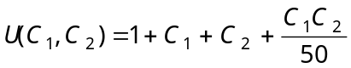

A particular indifference curve can be traced by setting U(C₁,C₂) equal to a constant and then varying C₁ and C₂. By changing the constant, we can trace out other indifference curves. For example, by setting U(C₁,C₂) equal to 50 we get:
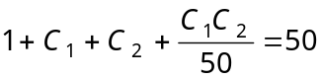or 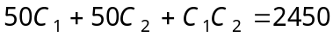

This indifference curve appears in the graph of the indifference map below as the curve labeled “50” (the lowest curve shown). By setting U(C₁,C₂) equal to 60, we get the curve labeled “60,” etc.
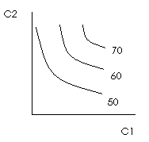
C. Solution

The optimum solution is where the opportunity set is tangent to the highest possible indifference curve (the point labeled “E” in the following graph).
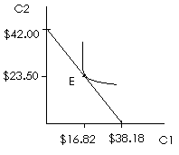
This problem is meant to be solved graphically. Below, we show an analytical solution:
Substituting the equation of the opportunity set given in part A for C₂ in the above equation gives:
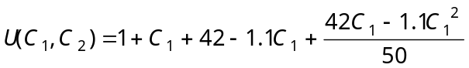
To maximize the utility function, we take the derivative of U with respect to C₁ and set it equal to zero:
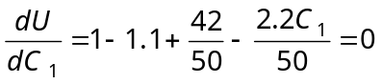
which gives C₁ = $16.82. Substituting $16.82 for C₁ in the equation of the opportunity set given in part A gives C₂ = $23.50.

Chapter 1: Problem 3

If you consume nothing at time 1 and instead invest all of your time-1 income at a riskless rate of 10%, then at time 2 you will be able to consume all of your time-2 income plus the proceeds earned from your investment:

$5,000 + $5,000 (1.1) = $10,500.

If you consume nothing at time 2 and instead borrow at time 1 the present value of your time-2 income at a riskless rate of 10%, then at time 1 you will be able to consume all of the borrowed proceeds plus your time-1 income:

$5,000 + $5,000 ÷ (1.1) = $9,545.45

All other possible optimal consumption patterns of time 1 and time 2 consumption appear on a straight line (the opportunity set) with an intercept of $10,500 and a slope of −1.1:

C₂ = $5,000 + ($5,000 − C₁) × (1.1) = $10,500 − 1.1C₁

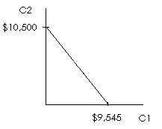

Chapter 1: Problem 4

If you consume nothing at time 1 and instead invest all of your wealth plus your time-1 income at a riskless rate of 5%, then at time 2 you will be able to consume all of your time-2 income plus the proceeds earned from your investment:

$20,000 + ($20,000 + $50,000)(1.05) = $93,500.

If you consume nothing at time 2 and instead borrow at time 1 the present value of your time-2 income at a riskless rate of 5%, then at time 1 you will be able to consume all of the borrowed proceeds plus your time-1 income and your wealth:

$20,000 + $50,000 + $20,000 ÷ (1.05) = $89,047.62

All other possible optimal consumption patterns of time-1 and time-2 consumption appear on a straight line (the opportunity set) with an intercept of $93,500 and a slope of −1.05:

C₂ = $20,000 + ($20,000 + $50,000 − C₁) × (1.05)

= $93,500 − 1.05C₁
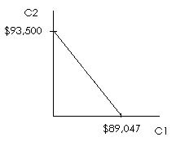

Chapter 1: Problem 5

With Job 1 you can consume $30 + $50 (1.05) = $82.50 at time 2 and nothing at time 1, $50 + $30 ÷ (1.05) = $78.60 at time 1 and nothing at time 2, or any consumption pattern of time 1 and time 2 consumption shown along the line AB: C₂ = $82.50 − 1.05C₁.

With Job 2 you can consume $40 + $40 (1.05) = $82.00 at time 2 and nothing at time 1, $40 + $40 ÷ (1.05) = $78.10 at time 1 and nothing at time 2, or any consumption pattern of time 1 and time 2 consumption shown along the line CD: C₂ = $82.00 − 1.05C₁.

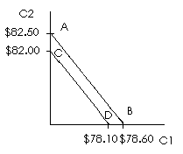
The individual should select Job 1, since the opportunity set associated with it (line AB) dominates the opportunity set of Job 2 (line CD).

Chapter 1: Problem 6

With an interest rate of 10% and income at both time 1 and time 2 of $5,000, the opportunity set is given by the line AB:

C₂ = $5,000 + ($5,000 − C₁) × (1.1) = $10,500 − 1.1C₁

With an interest rate of 20% and income at both time 1 and time 2 of $5,000, the opportunity set is given by the line CD:

C₂ = $5,000 + ($5,000 − C₁) × (1.2) = $11,000 − 1.2C₁

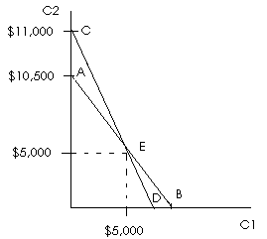

Lines AB and CD intersect at point E (where C₂ = time-2 income = $5,000 and C₁ = time-1 income = $5,000). Along either line above point E, the individual is lending (consuming less at time 1 than the income earned at time 1); along either line below point E, the individual is borrowing (consuming more at time 1 than the income earned at time 1). Since the individual can only lend at 10% and must borrow at 20%, the individual’s opportunity set is given by line segments AE and ED.

Chapter 1: Problem 7

For P = 50, this is simply a plot of the function 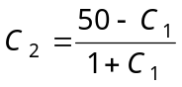.
For P = 100, this is simply a plot of the function 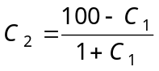.

Chapter 1: Problem 8

This problem is analogous to Problem 2. We present the analytical solution below. The problem could be solved graphically, as in Problem 2.

From Problem 3, the opportunity set is C₂ = $10,500 − 1.1C₁. Substituting this equation into the preference function P = C₁ + C₂ + C₁ C₂ yields:

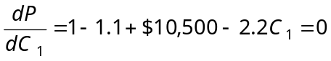
C₁ = $4,772.68
C₂ = $5,250.05

Chapter 1: Problem 9

Let X = the number of pizza slices, and let Y = the number of hamburgers. Then, if pizza slices are $2 each, hamburgers are $2.50 each, and you have $10, your opportunity set is given algebraically by

$2X + $2.50Y = $10

Solving the above equation for X gives X = 5 − 1.25Y, which is the equation for a straight line with an intercept of 5 and a slope of −1.25.

Graphically, the opportunity set appears as follows:

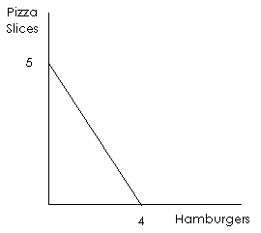

Assuming you like both pizza and hamburgers, your indifference curves will be negatively sloped, and you will be better off on an indifference curve to the right of another indifference curve. Assuming diminishing marginal rate of substitution between pizza slices and hamburgers (the lower the number of hamburgers you have, the more pizza slices you need to give up one more burger without changing your level of satisfaction), your indifference curves will also be convex.

A typical family of indifference curves appears below. Although you would rather be on an indifference curve as far to the right as possible, you are constrained by your $10 budget to be on an indifference curve that is on or to the left of the opportunity set. Therefore, your optimal choice is the combination of pizza slices and hamburgers that is represented by the point where your indifference curve is just tangent to the opportunity set (point A below).

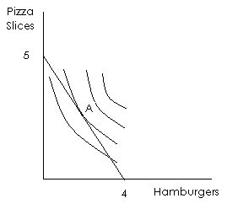

Chapter 1: Problem 10

If you consume C₁ at time 1 and invest (lend) the rest of your time-1 income at 5%, your time-2 consumption (C₂) will be $50 from your time-2 income plus ($50 − C₁)(1.05) from your investment. Algebraically, the opportunity set is thus

C₂ = 50 + (50 - C₁)(1.05) = 102.50 - 1.05C₁

If C₁ is 0 (no time-1 consumption), then from the above equation C₂ will be $102.50. If C₂ is 0, then C₁ will be $97.62. Graphically, the opportunity set appears below, along with a typical family of indifference curves.

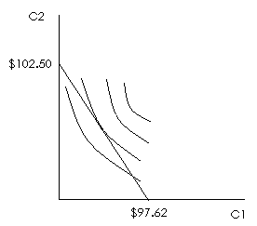

Chapter 1: Problem 11

If you consume C₁ at time 1 and invest (lend) the rest of your time-1 income at 20%, your time-2 consumption (C₂) will be $10,000 from your time-2 income plus $10,000 from your inheritance plus ($10,000 - C₁)(1.20) from your investment. The opportunity set is thus

C₂ = $10,000 + $10,000 + ($10,000 - C₁)(1.20) = $32,000 - 1.2C₁

If C₂ is 0 (no time-2 consumption), then you can borrow the present value of your time-2 income and your time-2 inheritance and spend that amount along with your time-1 income on time-1 consumption. Solving the above equation for C₁ when C₂ is 0 gives C₁ = $26,666.67, which is the maximum that can be consumed at time 1. Similarly, if C₁ is 0 (no time-1 consumption), then you can invest all of your time-1 income at 20% and spend the future value of your time-1 income plus your time-2 income and inheritance on time-2 consumption. From the above equation, C₂ will be $32,000 when C₁ is 0, which is the maximum that can be consumed at time 2.

Chapter 1: Problem 12

If you consume nothing at time 2, then you can borrow the present value of your time-2 income for consumption at time 1. If the borrowing rate is 10% and your time-2 income is $100, then the present value (at time 1) of your time-2 income is $100/(1.1) = $90.91. You can borrow this amount and spend it along with your time- income of $100 on time-1 consumption. So the maximum you can consume at time 1 is $90.91 + $100 = $190.91. If you consume nothing at time 1 and instead invest all of your time-1 income of $100 at the lending rate of 5%, the future value (in period 2) of your period 1 income will be $100(1.05) = $105. You can then spend that amount along with your time 2 income of $100 on time-2 consumption. So the maximum you can consume at time 2 is $105 + $100 = $205. With two different interest rates, we have two separate equations for opportunity sets: one for borrowers and one for lenders.

If you only consume some of your time 1 income at time 1 and invest the rest at 5%, you have the following opportunity set: C₂ = 100 + (100 - C₁)(1.05) = 205 - 1.05C₁. If you only consume some of your time-2 income at time 2 and borrow the present value of the rest at 10% for consumption at time 1, your opportunity set is: C₁ = 100 + (100 - C₂)/(1.1) = 190.91 - C₂/1.1,or, solving the equation for C₂,
C₂ = 210 - 1.1C₁

Graphically, the two lines appear as follows:

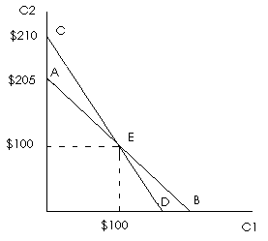

The lines intersect at point E (which represents your income endowment for times 1 and 2). Moving along the lines above point E represents lending (investing some time-1 income); moving along the lines below point E represents borrowing (spending more than your time-1 income on time-1 consumption). Since you can only lend at 5%, line segment AE represents your opportunity set if you choose to lend. Since you must borrow at 10%, line segment ED represents your opportunity set if you choose to borrow. So your total opportunity set is represented by AED.

